**PROJECT TITLE (24pt. bold)**

**PROJECT SYNOPSIS (14pt. bold)**

OF 6 MONTHS INDUSTRIAL TRAINING (12pt.)

**BACHELOR OF TECHNOLOGY** (14 Pt. bold)

## Branch (16pt.)

SUBMITTED BY

(12pt.)

Name:

Roll No.



**CGC COLLEGE OF ENGINEERING, MOHALI**

**(16pt. bold)**



ABOUT US

# Future Finders is a ground-breaking platform that develops young Indian talent that is motivated to advance and forge successful careers in IT. We provide a variety of courses to help you launch your career and locate the employer that will assist you as you rise to the top. Our expertise with the latest tools and techniques, and the experience of our professional experts help us deliver high-end services to our esteemed clients. Future Finders educates students and developers about the most recent technologies that are now popular. We are working on distributing informational know-how and offering clients specialized services following global best practices. At Future Finders, we recognize your unrivalled skill and help you realize your creative ideas. Our sole goal is to provide students with cutting-edge practical skills that will enable them to swiftly and effectively adapt to the constantly evolving technologies found in the business world. At Future Finders, our goal is to raise educational standards via innovation in both quality and practical knowledge.



**MISSION**

* At Future Finders, our goal is to improve quality and practical skills while raising the bar for education. Future Finders' principal objective is to bridge the knowledge gap between what is being taught in schools and what the industry needs.

**VISION**

* Future Finders' vision is to provide students with cutting-edge practical skills so they can easily handle and swiftly acclimate to the constantly evolving technology in the corporate world.

**PHILOSOPHY**

# To impart hardcore practical quality training among students/developers about latest technologies trending today.

To share knowledge of information security and create awareness in the market. The solution to clients' as per the International standard practices and governance.

# To support good business practices through continual employee training and education

To equip a local team with a strong knowledge of international best practices and international expert support so as to provide practical advisories in the best interests of our clients

   

* JAVA
* FULL STACK
* C LANGUAGE
* C++ LANGUAGE
* CYBER SECURITY
* MERN STACK
* PYTHON
* DIGITAL MARKETING
* PHP
* NETWORKING
* ANDROID
* IOS
* .NET
* ORADE DBA
* SOFTWARE TESTING
* ETHICAL HACKING
* MACHINE LEARNING
* BIG DATA HADOOP
* NODE JS
* ANGULAR JS
* CLOUD COMPUTING
* AUTO CAD
* NETWORKING
* ROBOTICS
* VLSI – VHDL
* PCB
* MATLAB
* EMBEDDED SYSTEM
* IOT
* PLC / SCADE
* ARDUINO
  + NX- CAM
  + AUTOCAD ME
  + SOLID WORKS
  + CATIA
  + CREO
  + CNC PROGRAMMING
  + ANSYS
    - MARKETING
    - DIGITAL MARKETING
    - FINANCE
    - HR MANAGEMENT
  + AUTOCAD CE
  + PRIMA VERA
  + MX ROAD
  + 3DS MAX
  + REVIT ARCHITECTURE
  + STAAD PRO

CSE & IT

ECE & EE

MECHANICAL

CIVIL

MANAGEMENT

Why choose us:

 Experience

 Goal Oriented

 A Streamlined / Quality-Driven Process  Talented Designers & Expert Developers

 Our Websites & E-marketing Platforms are Easy to Manage  We Are Dedicated to Our Client’s Success

## We focus on imparting practical skills to the trainees & not just theoretical knowledge. The courses are designed in this way at FUTURE FINDERS correspond to the standards of the corporate divisions and industries. Only through the acquisition of practical skills you can handle the everlasting technologies that venture out in real-time situations**.**

* At **FUTURE FINDERS,** Future Finders has committed staff members with organised learning curricula that can assist you in beginning your career in the most cutting-edge and successful industries.

* **Quality of the Product:** Our software service sector has been maintaining the highest international standards of quality.

## * **Live projects:** Working on active projects and working at a job aid in experiencing growth. In keeping with this, we assist you in developing greater self-assurance, which helps you succeed as quickly as feasible.

* **Global certification:** The courses that Future Finders offers make sure that you are certified and eligible to grab the best opportunities in your career.

## * **Partnership:** FUTURE FINDERS, considers every client a partner. From the initial stages, you are closely involved into the procedure of technical classification, development, and testing.

* **Jobs & Career Prospective:** Future Finders views education and learning as investments in oneself. Consequently, the paths we have set forth ensure that your investment in us is a success



* In addition to a panel of eminent consultants and advisors, we have a dedicated pool of trained Developers and Trainer, investigators, working under the guidance of professional managers. **“A Ship is as good as the crew who sail her**.**”** Our Technical team of professionals handing, designing & delivering of projects has a strong presence in the North India & the US. Our engineers are already working on the latest technologies like **I-Phone & Android** Applications, **Robotics**, **VLSI-VHDL**, Embedded System, Networking and **Cloud computing.** Some of the key professionals and advisors are listed

### Mr. Bonish Singla: (Director)

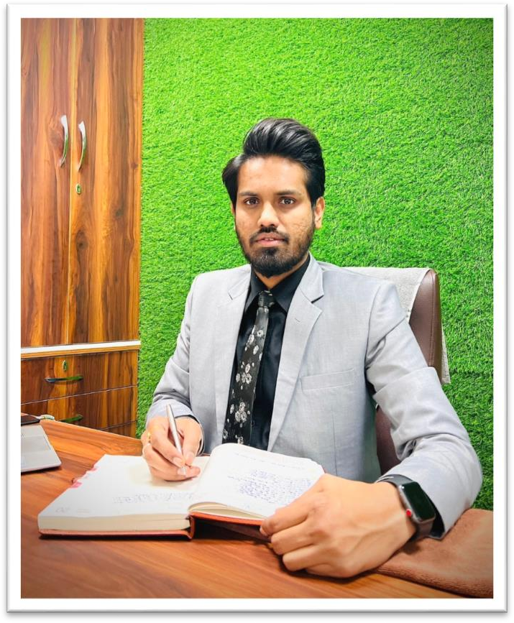

* He is the backbone of FUTURE FINDERS, manage the company’s day to day affairs and a man with more than 9 years rich practical experience who believes in taking up new ventures and projects. He has been awarded many times for his exemplary work in process improvement for IT Service Delivery Domains. MASTERS in Computer applications and Certified from CU Certification. Holds total of 9 Years of rich experience including 5 Years in Information Security Implementation, Maintenance and Auditing and initial over 4 years of experience in Project Management, Client Relationship Management and Server, Desktop, and IT Service Delivery web designing.

### 

### Miss. Harjit Kaur :(Branch Manager)

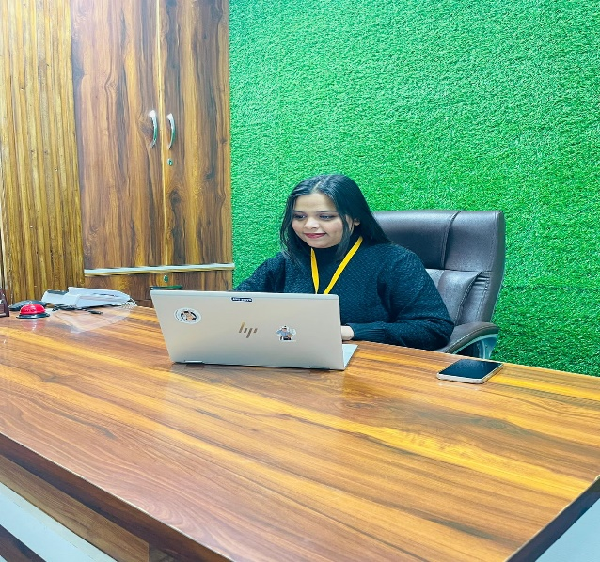

* She has more than 5 years solid industrial experience in software companies and she is very innovative in her technical approach. She has completed her masters in MBA. She takes all the responsibilities and maintains staff by recruiting , selecting , orienting , and training employees and Accomplishes staff results by communicating job expectations , planning ,monitoring , and appraising job results.

### Miss. Harsimran: (HR)

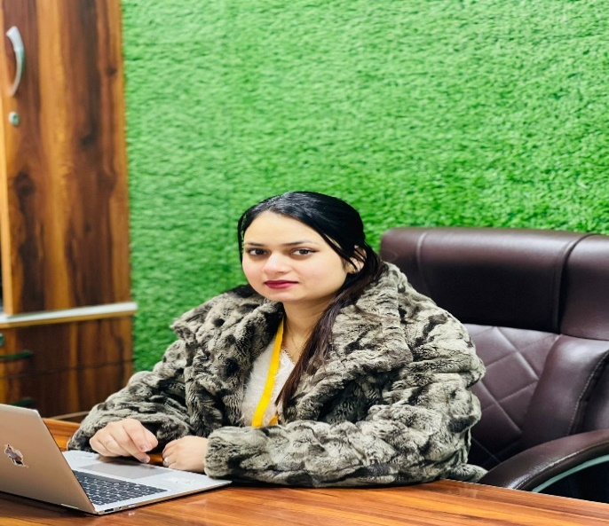

* Human resources (HR) are the division of a business responsible for finding, recruiting, screening, and training job applicants. MBA in HR and marketing from (CU) Total of 5+ Years of rich experience HR departments also handle employee compensation, benefits, and terminations. HR departments must keep up to date with laws that can affect the company and its employees. She also assists with payroll management so employees receive their paychecks on time.

### 

### Miss. Isha Bala: (Technical Head)

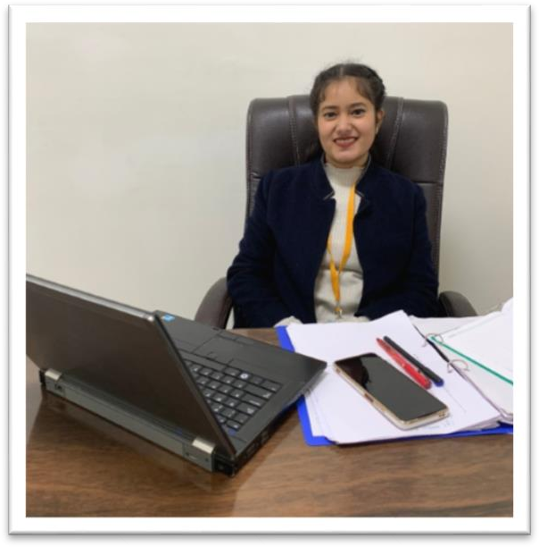

* A technical lead, or tech lead, oversees the technical aspects of a software team. M. tech and diploma in (CSE) . She helps making architectural and design decisions, guiding team members, and supervising system modifications. Identify potential risk and forming contingency plan as fast as possible. Efficiently liaise with the team members, clients , and also the management .

### Miss. Nihirika: (Head Counselor)

### 

* Head Counselor, under the general direction of the Head - Sales and Marketing, provides leadership and direction to the Counseling Department and assumes responsibilities in developing, implementing, and evaluating the Company counseling and guidance program that includes academic, career, personal/social development. She completed her degree in B .Tech

### 

### Mr. Jaspal Singh: (Civil &Mechanical Head)

* He is leader of the team of civil, mechanical, and electrical engineers and responsible for the planning and analysis of the aspect of the construction that involves mechanical works . He has more than 37 years of experience in industrial field. He is providing services as a technical trainer for more than 8 years. He did his B. Tech in Mechanical Engineering from PEC (Punjab Engineering College). He has been awarded many times for his brilliant services.

### Mr. Chetan Kalra: (Digital Marketing Head)

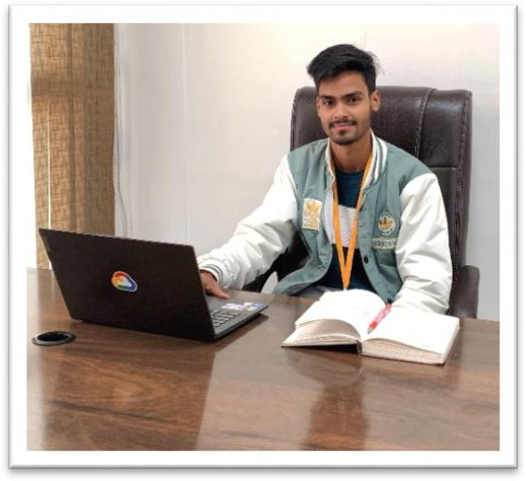

* B.tech (CSE) – IKG-PTU, Experienced digital marketing manager with extensive experience building, maintaining, and running successful digital marketing campaigns from past 4 years. Bringing forth broad marketing knowledge, coupled with focused campaign experience. Adept at creating and implementing client- centered, successful campaigns, aimed at improving brand awareness and presence. Collaborative and creative manager accomplished at managing digital marketing presence content. Experienced in leading teams of marketing professionals to meet and exceed digital marketing goals.



Mr. Shivam: (Java Developer)

### 

Having 5+ years of experience in analysis, design, development, testing & implementation of complex software applications. B. Tech in CSE (CGC College) Experience and involvement in designing, implementing, and evaluating end-to-end systems using several Java frameworks and technologies like J2EE.

### Miss. Archana: (Full Stack Developer)

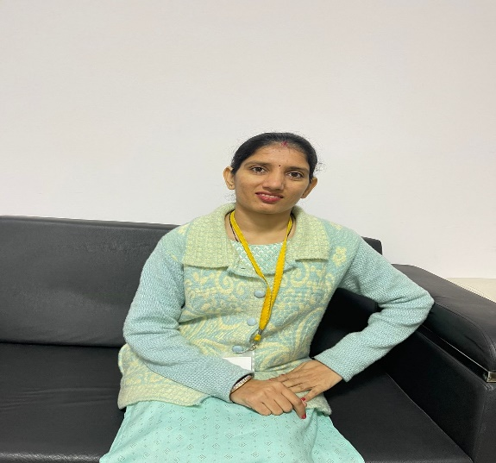

* Full Stack Developer with 6+ years of hands-on experience designing, developing, and implementing applications and solutions using a range of technologies and programming languages. B.tech (CSE) PU Certification Seeking to leverage broad development experience and hands-on technical

### 



Plot NO F-465, K&B Tower, Second Floor, Phase 8B, Mohali I (+91) 98559-08009 I [www.futurefinders.in](http://www.futurefinders.in/)

### Mr. Ashwani: (Automation Executive)

### 

* (EE) – CGC College Automation engineer with 4+ years of experience in a variety of industries. Passionate for developing and implementing process improvements through the use of robotics, PLCs, and HMIs. Demonstrated ability to lead cross-functional teams in the design, development, and deployment of manufacturing and process automation solutions.

### Mr. Ayush: (PHP Developer)

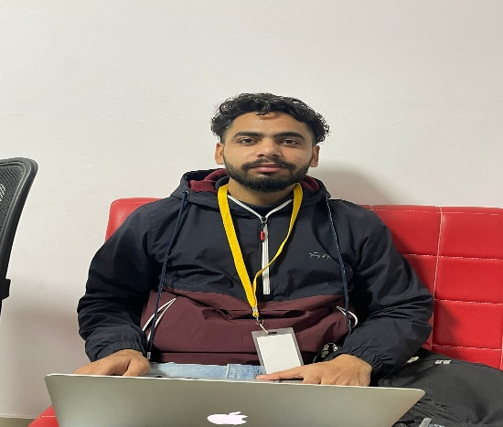

* PHP developer to manage our back-end services and ensure a seamless interchange of data between the server and our users. Bachelor's degree in computer programming, development and Certified from CU Certification PHP developer, responsible for developing and coding all server-side logic and required to maintain the central database and respond to requests from front-end developers

**INTRODUCTION**

In today's digital era, Automated Teller Machines (ATMs) play a pivotal role in modern banking systems, offering customers convenient access to financial services round the clock. To understand the intricate workings of an ATM and its underlying mechanisms, the ATM Simulator Java Project emerges as a comprehensive endeavor.

The ATM Simulator Java Project aims to replicate the functionality of a real-world ATM system within a virtual environment. Through the use of Java programming language, this project endeavors to provide users with a simulated ATM experience, facilitating learning, experimentation, and understanding of fundamental banking operations.

It elucidates the significance of such a simulation in fostering understanding and proficiency in banking systems and Java programming concepts. Furthermore, it delineates the potential applications and benefits of utilizing the ATM Simulator as a learning tool in educational institutions, software development firms, and banking organizations.

With an emphasis on modularity, efficiency, and user experience, the ATM Simulator Java Project endeavors to offer a seamless interface for users to perform a myriad of banking transactions, including balance inquiries, cash withdrawals, fund transfers, and account management operations. By adhering to industry standards and best practices, this project aims to encapsulate the complexity of real-world ATM systems while maintaining simplicity and intuitiveness in its user interface.

Through collaborative efforts and meticulous design, the ATM Simulator Java Project aspires to contribute to the educational landscape by providing a practical and interactive platform for students, developers, and banking professionals to explore the intricacies of ATM operations, refine their programming skills, and gain insights into the inner workings of modern banking systems.

**FEASIBILITY STUDY**

The feasibility study for the ATM Simulator Java Project aims to assess the practicality, viability, and potential success of developing a comprehensive ATM simulation system using Java programming language. This study evaluates various aspects including technical, economic, operational, and scheduling feasibility to determine whether the project is worth pursuing.

**Technical Feasibility:**

* Java programming language offers robust support for building complex applications, making it suitable for implementing the ATM Simulator.
* Availability of Java libraries and frameworks for user interface design, database integration, and network communication enhances development efficiency.
* Evaluation of technical challenges such as security protocols, transaction handling, and concurrent processing is crucial to ensure the feasibility of the project.

**Economic Feasibility:**

* Cost analysis including development tools, hardware infrastructure, personnel expenses, and maintenance overheads is essential to determine the economic feasibility of the project.
* Consideration of potential revenue streams, such as licensing fees, consulting services, and partnerships, can offset development costs and contribute to long-term sustainability.
* Comparative analysis with existing ATM simulation solutions and market demand projections help gauge the project's financial viability and return on investment.

**Operational Feasibility:**

* Assessment of user requirements, functionality expectations, and performance benchmarks is imperative to ensure operational feasibility.
* User acceptance testing, usability studies, and feedback mechanisms enable iterative refinement of the ATM Simulator to meet user expectations and industry standards.
* Alignment of project goals with organizational objectives, stakeholder expectations, and regulatory compliance is crucial for seamless integration into operational workflows.

**Scheduling Feasibility:**

* Development timeline, resource allocation, and milestone planning should be realistic and achievable within the specified timeframe.
* Identification of potential risks, dependencies, and contingencies enables proactive mitigation strategies to mitigate project delays and budget overruns.
* Agile methodologies such as Scrum or Kanban facilitate iterative development, rapid prototyping, and adaptive planning to ensure timely delivery of project milestones.

**METHODOLOGY**

The methodology and planning of work for the ATM Simulator Java Project provide a structured approach to the development, implementation, and deployment of the simulated ATM system. This section outlines the systematic framework, methodologies, and timelines essential for executing the project effectively.

**Project Scope Definition:**

* Define the scope of the ATM Simulator Java Project, including key features, functionalities, and target audience.
* Identify the core objectives, deliverables, and success criteria to guide project planning and execution.
* Establish clear boundaries and constraints to ensure project feasibility and manage stakeholder expectations effectively.

**Requirement Analysis:**

* Conduct a comprehensive analysis of user requirements, business objectives, and technical specifications to inform system design and development.
* Elicitation of functional and non-functional requirements through stakeholder consultations, market research, and domain analysis.
* Prioritize requirements based on their criticality, relevance, and impact on system performance and user experience.

**System Design:**

* Develop high-level and detailed design specifications outlining the system architecture, data model, user interface, and component interactions.
* Utilize UML diagrams, flowcharts, and mockups to visualize system design and facilitate stakeholder review and feedback.
* Ensure modularity, scalability, and extensibility in system design to accommodate future enhancements and technological advancements.

**Development and Implementation:**

* Adopt an iterative and incremental development approach, leveraging agile methodologies such as Scrum or Kanban to promote collaboration, flexibility, and adaptability.
* Implement core functionalities of the ATM Simulator using Java programming language, adhering to coding standards, best practices, and design patterns.
* Conduct rigorous testing, debugging, and validation to ensure software quality, reliability, and compliance with functional requirements.

**Integration and Testing:**

* Integrate individual components and modules of the ATM Simulator into a cohesive system, addressing dependencies, interoperability issues, and data consistency.
* Conduct systematic testing including unit testing, integration testing, system testing, and acceptance testing to verify functional correctness and performance efficiency.
* Employ automated testing tools, test scripts, and regression testing techniques to streamline the testing process and accelerate feedback cycles.

**FACILITIES REQUIRED**

The successful development and implementation of the ATM Simulator Java Project necessitate access to various facilities and resources to support the project's objectives effectively. This section delineates the fundamental facilities required to facilitate the development, testing, and deployment of the ATM Simulator.

**Hardware Infrastructure:**

* Adequate hardware resources including desktop computers, laptops, and servers are required to support software development, testing, and deployment activities.
* High-performance computing resources such as multi-core processors, ample RAM, and solid-state drives (SSDs) enhance development productivity and system performance.
* Virtualization technologies and cloud computing platforms offer scalability, flexibility, and cost-efficiency in provisioning computing resources for development, testing, and production environments.

**Software Tools and Libraries:**

* Access to a comprehensive suite of software tools, libraries, and frameworks is indispensable for developing, testing, and deploying the ATM Simulator.
* Java Development Kit (JDK) provides essential tools and libraries for Java application development, including the Java Runtime Environment (JRE) and Java Standard Edition (Java SE) APIs.
* JavaFX or Swing frameworks facilitate the development of graphical user interfaces (GUIs) for the ATM Simulator, enabling interactive user interactions and seamless navigation.
* Database management systems (DBMS) such as MySQL, PostgreSQL, or SQLite support data storage, retrieval, and management functionalities for storing user accounts, transaction logs, and system configurations.

**BIBLIOGRAPHY**

1. "Design and Implementation of a User-Friendly ATM Simulator," by Nduka Eze, Oluwatoyin Olabisi Olaniyi, and Adeola Mathew Adeyanju, International Journal of Engineering and Applied Sciences, vol. 7, no. 3, pp. 66-73, 2017.
2. "Development of a Simulation Tool for Automatic Teller Machines (ATMs)," by Denis C. Chiş, Alexandru B. Pop, and Adrian M. Ghencea, Proceedings of the 11th International Conference on Applied Informatics, vol. 1, pp. 189-194, 2014.
3. "Simulation of ATM Using Queuing Theory," by S. K. Agrawal and Vaishnavi G. Kulkarni, International Journal of Computer Science and Mobile Computing, vol. 3, no. 2, pp. 349-356, 2014.
4. "Design and Implementation of ATM Simulation System Based on MVC Pattern," by Zhao Li and Li Ping, Proceedings of the 2011 International Conference on Electronics, Communications and Control, pp. 2027-2030, 2011.
5. "Design and Development of an ATM Simulator for Information Security Education," by Tsutomu Matsumoto, Hiroshi Yasuda, and Hiroaki Hazeyama, Proceedings of the 2006 ACM Workshop on Digital Identity Management, pp. 33-40, 2006.